**Newsletter-February 2020**

**Headteacher’s Update**

We’ve had a very exciting half term, as we have launched our new Advantage Curriculum and have had some new and different things going on!

Year 3 participated in a day of dance workshops yesterday, where they got to try out Street, Bollywood and Flamenco dancing. This was part of our ‘Passion’ link, where we are encouraging children to try out new and different ways of being creative and exploring the arts. They all tried to join in with as much as they could and I was amazed at how quickly they picked up the moves and choreography!

Year 4 and 5 have both been doing projects in our ‘Accountability’ link, where we are encouraging the children to learn about the environment and nature. Year 4 have been creating new products from plastic bottles in order to re-use and recycle, and have made everything from pen pots to toys, all while saving the plastic from going to landfill. Year 5 have planted different herbs, salads and vegetables, and we hope to be able to harvest these later to be able to create some foods with ingredients they have produced themselves from seeds. Some of their crops are already growing well - they must be doing a fantastic job!

Year 6 have been working on the ‘Aspiration’ link, where we look at careers and enterprise. They went on a trip to KidZania in London, where they got to earn KidZos by working in different jobs roles in a city run by kids! They had a great time, and a member of the public spoke to the teachers to say how polite and respectful our children were, which is always a lovely thing to hear. Well done!

It has been lovely to see how enthusiastically the children have joined in with these new areas of learning - I cannot wait for the exciting things coming up next!

A huge thank you to those of you who attended our Termly Learning Conferences this week, both on the main evening, and those of you who have scheduled a different appointment with the teacher. It’s always a really positive evening, where the children really enjoy sharing what they are proud of.

**I hope that you all have a lovely half term break, and we look forward to seeing you again on Tuesday 25th February 2020.**

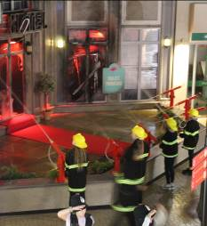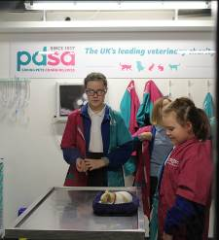

**KidZania**

Our Year 6 pupils embarked on a very exciting trip to KidZania this month to experience some tasters in careers and aspirations. All of the children took full advantage of the day and enjoyed experiencing different careers. It was a wonderful day and the children were so well behaved.

Please take a look at the website for more information about the trip and more pictures of the day.

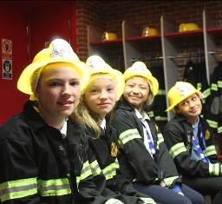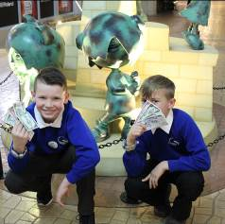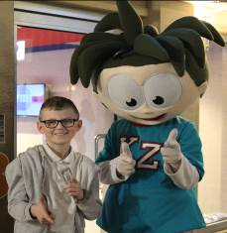

**Dance Workshop Day**

Our Year 3 pupils had a fun day this week taking part in a Dance Days workshop. They learned the art of Street dance, Flamenco and Bollywood dancing. They had great fun participating in different cultural dances and some were able to show off some very impressive moves!

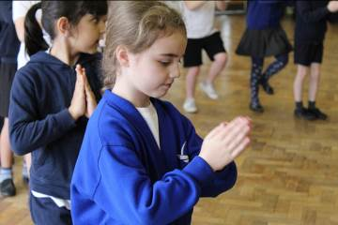

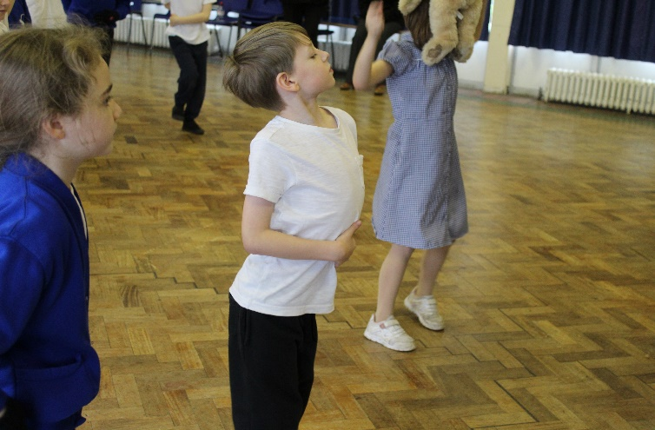

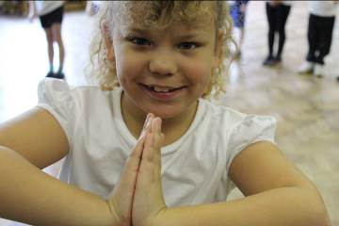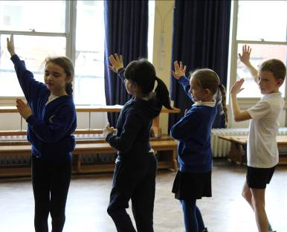

**Year 5 Planting Project**

Year 5 have been busy planting herbs and vegetables this term with a view to make some delicious treats at the end of the process. Knowing where our food comes from is important to understand sustainability of food sources. We are so happy to see that some have started to produce shoots already!

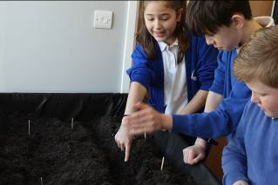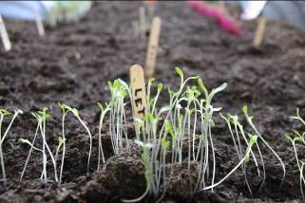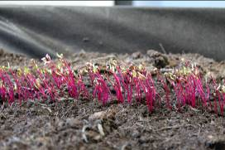

**Year 4 Recycling Project**

Our Year 4 pupils have been getting creative this term by recycling their plastic goods. This is to help them understand accountability and what It means to the environment to recycle goods.

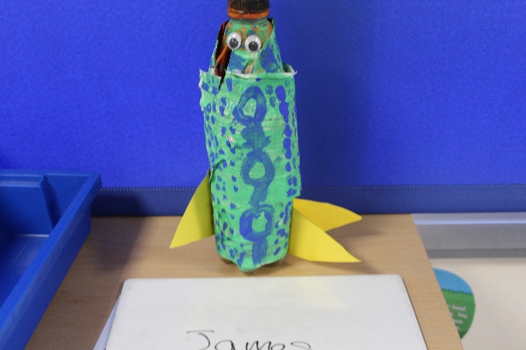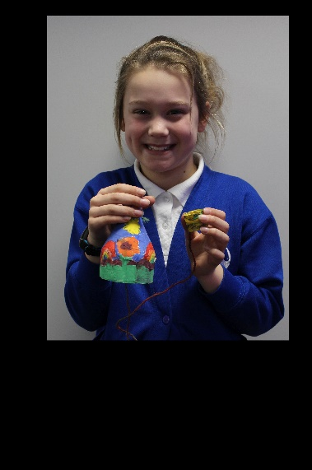

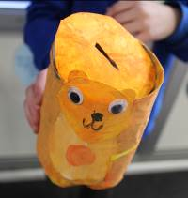

**World Book Day**

We are very excited for world book day 2020. It will be held on Friday 6th March 2020 and we are looking forward to see what costumes you all have in store.

This year as well as fancy dress we are running a competition where pupils are asked to transform a potato into a well-known book character!

There will be a prize awarded for the best dressed potato in each class.

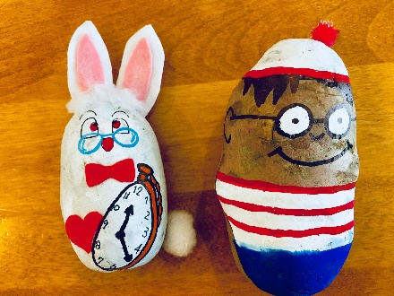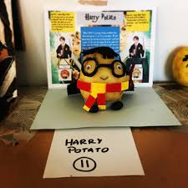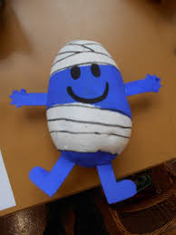

**Upcoming Dates**

14th February- Last day of half term.

24th February- Non Pupil Day

25th February- Children to return to school

2nd March- 6th March- Book Week

2nd March- Netball Match Vs Kelvedon (home)

6th March- World book day dress up day.

19th March- YR 3 Duxford trip (more information to follow)

3rd April- Easter Egg Hunt

3rd April- Last day of Term

More information about these dates will come to you nearer the time.