Newsletter-November 2019

Headteacher’s Update

The children have come back well following half term, and have been busy getting back into learning. I have seen some excellent learning when I have visited classrooms this week!

Years 3 and 5 had a fantastic time at their Stone Age experience days. All of them joined in enthusiastically with our cavepeople, and found out lots about what life was like for the people of the UK all that time ago. We were very proud of how sensible and polite they were, and our visitors commented that were one of the best groups they’ve ever worked with! Well done, everyone!

Our PTA have lots of fabulous events planned for this year, and are looking at some of the favourite activities from last year, as well as some new ones! They are starting the year off with our very first Glow Disco on 28th November, which we are very excited for! The last day to purchase tickets will be Monday 25th November. We are looking forward to seeing lots of you there. Thank you to the PTA who are so committed to raising money for our school.

Please remember that next Friday, 29th November, is a non-pupil day.

Caveman for a day
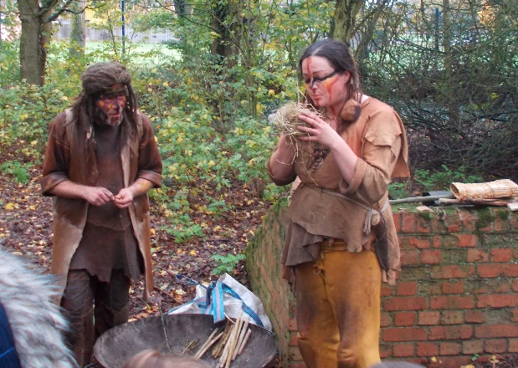
Last week we had a visit from some cavemen, Memma and Twig. They turned the studio into a cave, and allowed the children to explore what it was like to be a caveman for the day! The children thoroughly enjoyed their visit and took part in lots of activities. Please take a look at the website for some more pictures of the day.

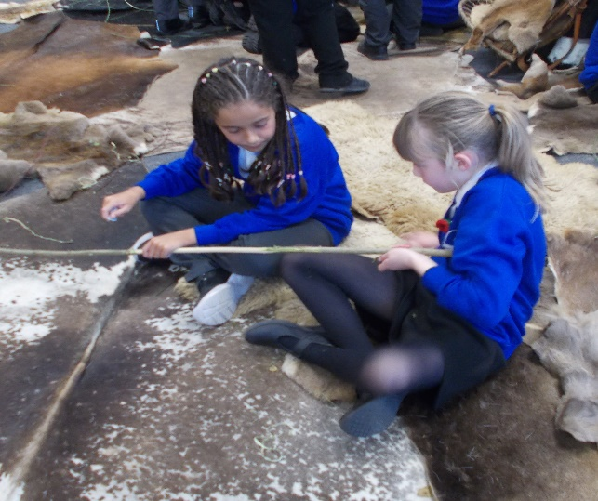
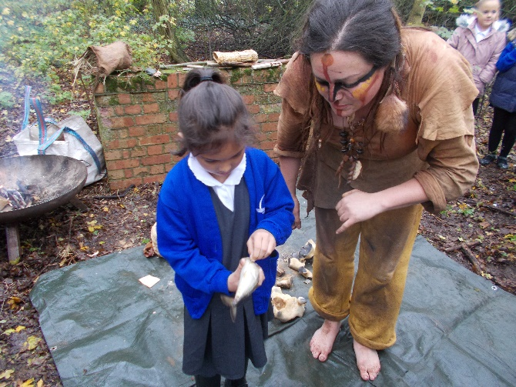
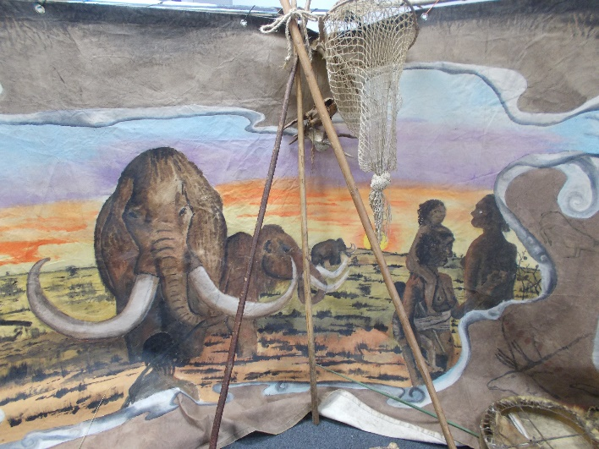

Children In Need
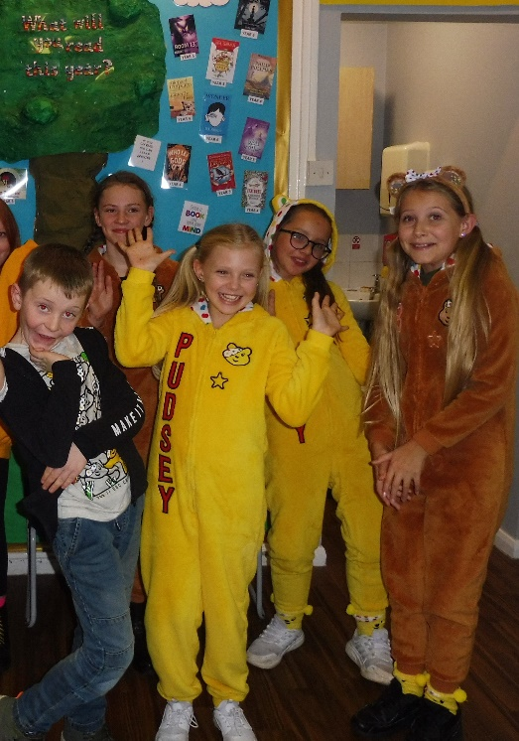
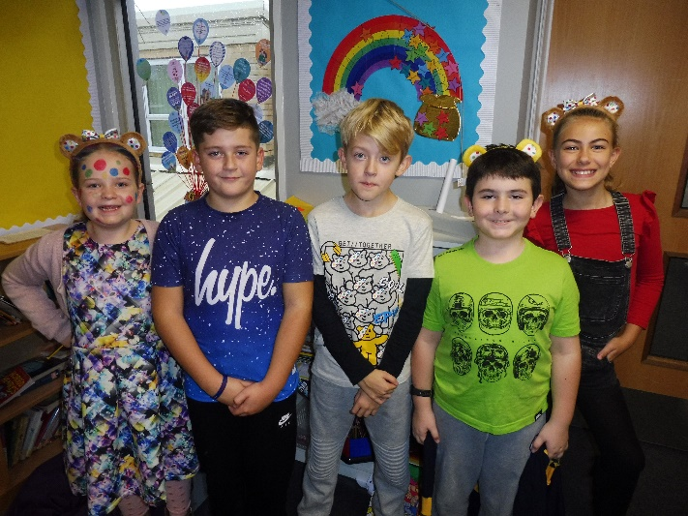
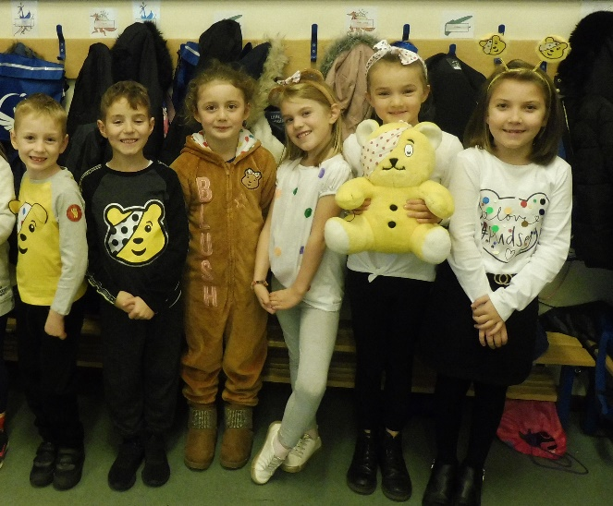

We had an amazing selection of Children in Need non-uniform outfits this year, with some fabulous onesies included! We raised a very impressive £200 for the charity and we are grateful to all that donated.

Berechurch Family Hub
Berechurch Family Hub are now running after school activities for school aged children. They have Move it Mondays, Construction Challenge Tuesday and Health and wellbeing drop in on Thursday. This is a great way of receiving a little extra support and would be a fantastic way of meeting other local parents. Although they are focused on school aged children you are welcome to take younger siblings too.
If you would like more information about the activities, please visit the School Office.

Crisp Packet Collection
Our crisp packet recycling collection is still taking place in school. Walkers have now found a way to recycle crisp packets and will take used crisp packets from any brand! Please remind children to use the dedicated bins so that we can keep this going.

Upcoming Dates

28th November 2019- Friends of Monkwick Glow Disco
29th November 2019- Non-Pupil Day
2nd December 2019- Flu Vaccinations
2nd-6th December 2019- Book Fair
11th December 2019- Friends of Monkwick Santa’s Grotto
13th December 2019- Christmas Jumper Day & Pantomime at the TLA
16th December 2019- Rev. Jackie Sams Assembly.
17th December 2019- Year 3 & 4 Christmas dinner
17th December 2019- Year 5 Christmas Carols @ 2:15pm
18th December 2019- Year 5 & 6 Christmas dinner
18th December 2019- Year 4 Christmas Carols @ 2:15pm
19th December 2019- Year 3 Christmas Carols @ 2:15pm
20th December 2019- Last day of Term

More information about these dates will come to you nearer the time.

