Newsletter – October 2019

Headteacher’s Update

We’ve had a very busy, enjoyable start to the year, and it feels like it has flown by so far! All of our year 4, 5 and 6 children have come back beautifully and got straight back into their learning. I’ve been very impressed with how grown up they have been and what fantastic examples they are setting. Our new year 3 children have settled in very well, and they should be proud of how hard they are working and how enthusiastic they are about their learning! Well done everyone!

I’ve been very lucky this week, as I have been spending time in classes looking at what the children have been learning. I’ve been really impressed with so many of our children who have been joining in and trying new things out, and it’s been lovely to see some of the children using our new music studio!

Hopefully you will have noticed that the new fence is going up! The parts still waiting for completion are those around the gates, which are planned for during the half term break. We are not expecting things to be too different when we return to school on the Monday after half term, but if anything has changed, staff will be outside to help everyone get to the right spot.

It has also been lovely to meet so many of our new parents and families, and to welcome back our existing ones. Please remember that there is always someone that can help if you have any questions in your time with us!

Bloom

Bloom is our brand new space to support our children. We have a range of brand new resources for our children to use. Bloom is located within the middle of the school so it is easily accessible for all children. It is divided into clearly defined zones, including sensory, learning, calming and relaxing! The purpose of Bloom is to provide children with the tools and strategies they need to be able to access their leaning in class. We are thankful to Mrs Watts, Mrs King and Mrs Hogg for all the hard work they have done in setting everything up!
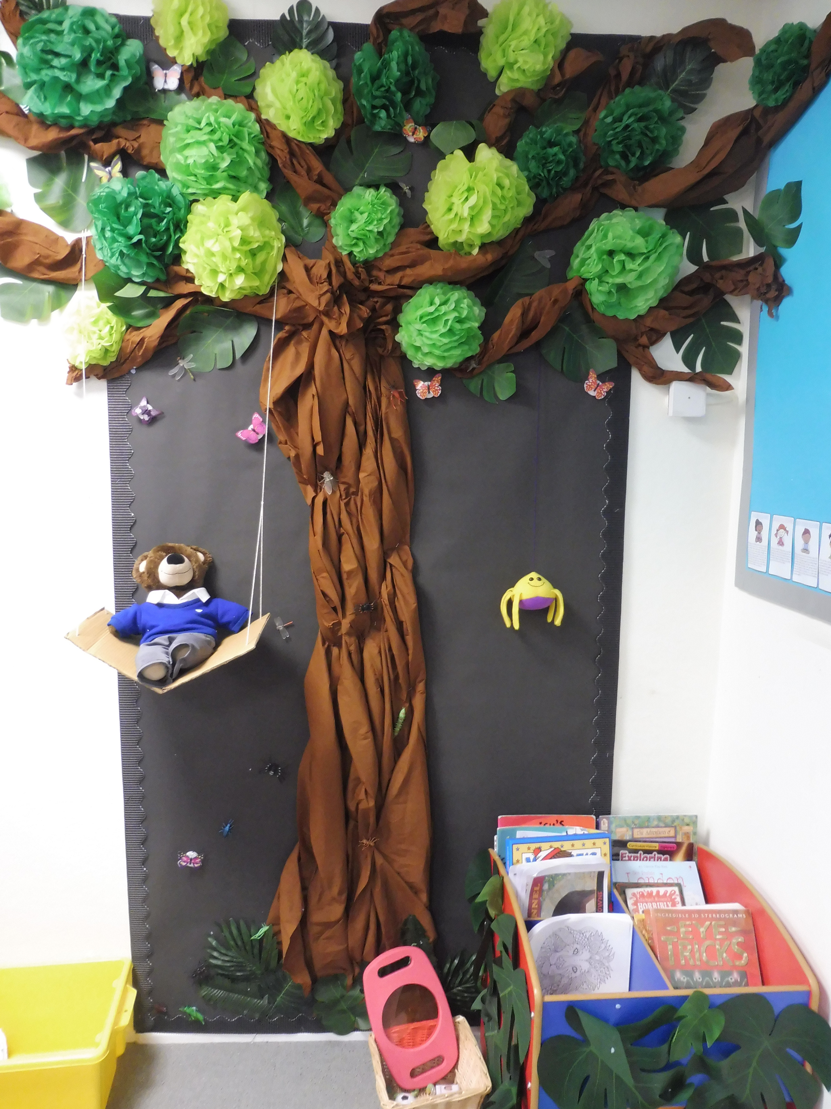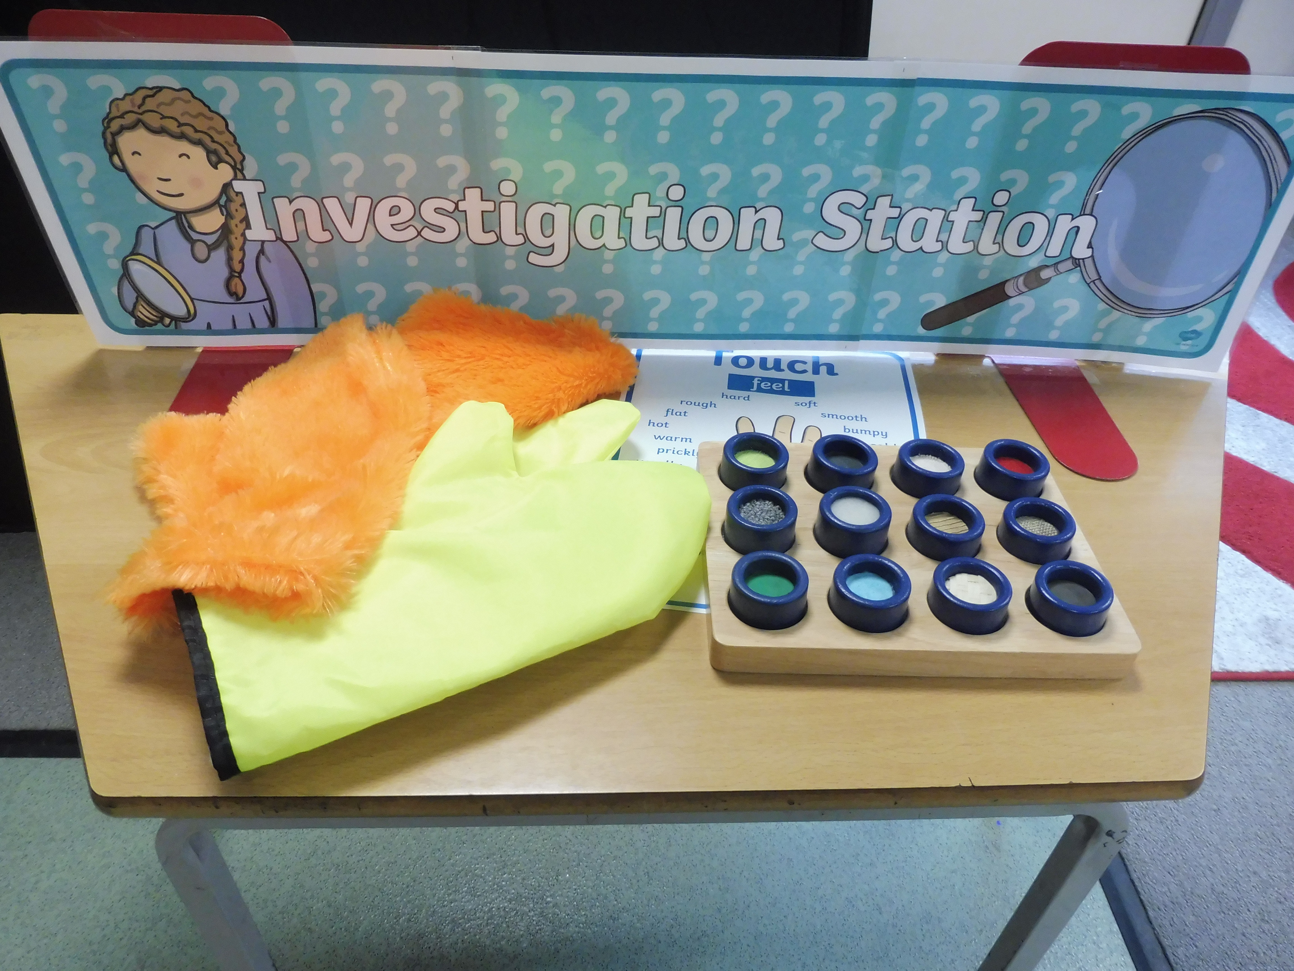
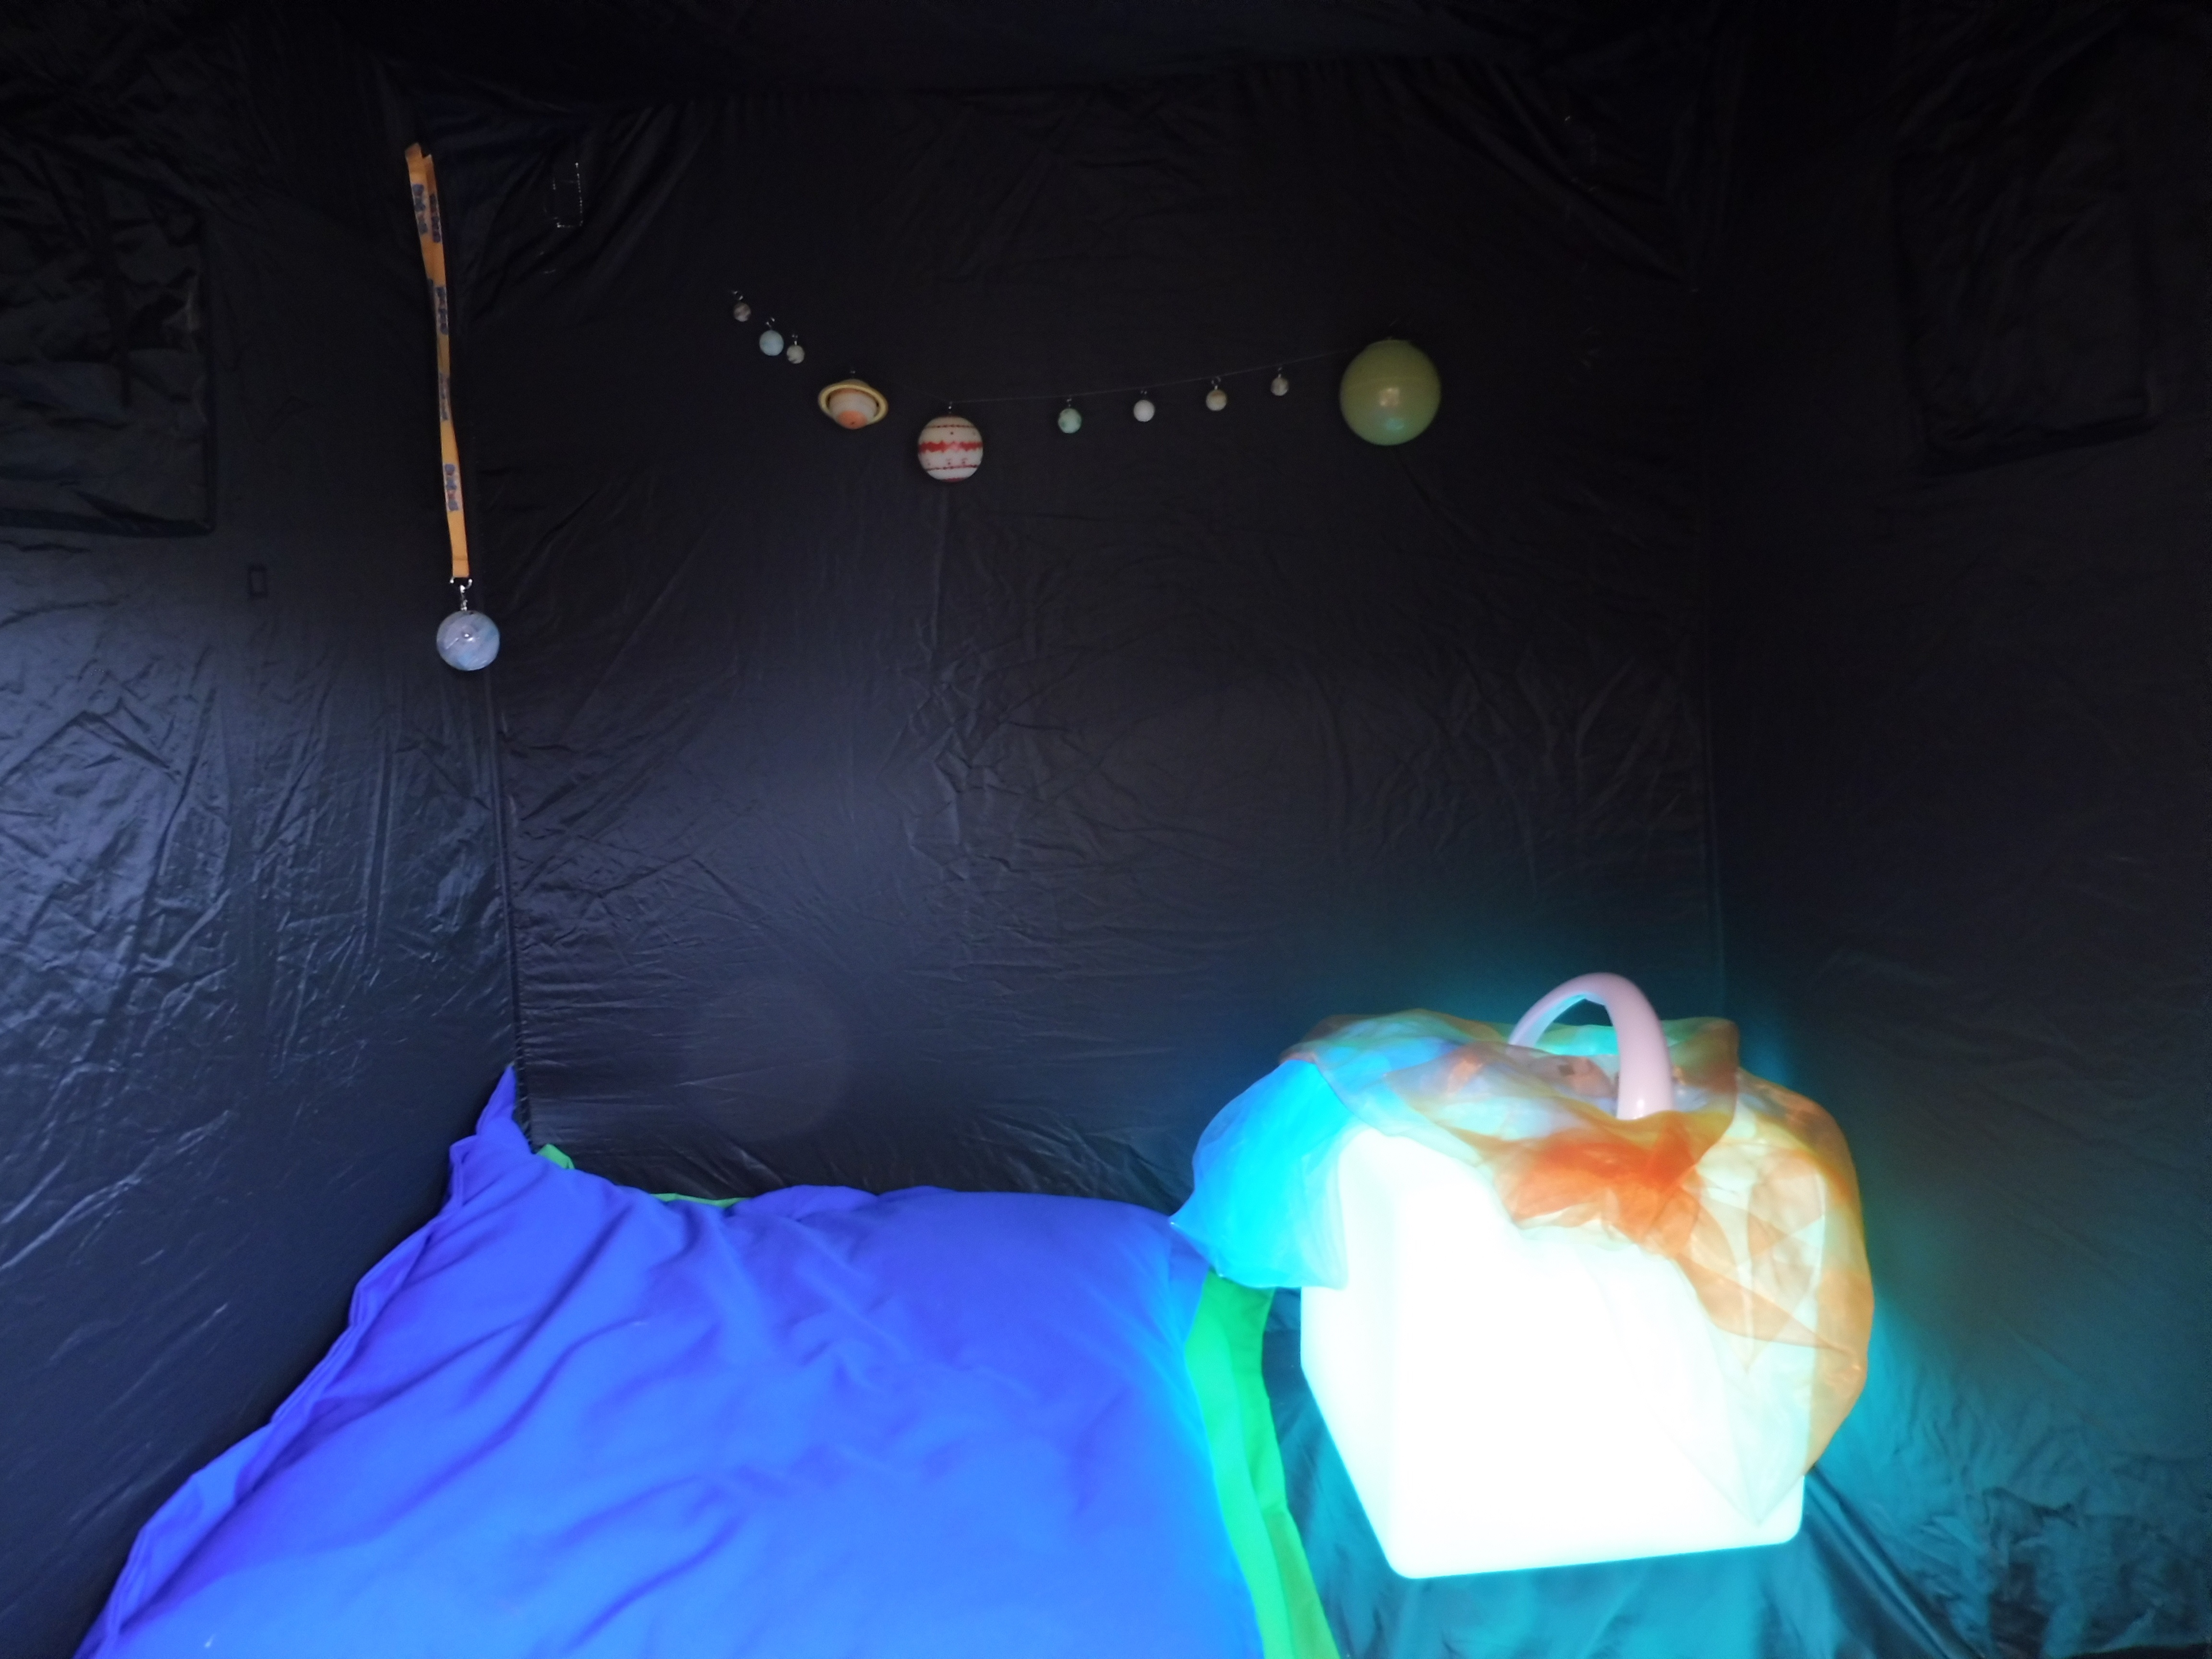

School Council
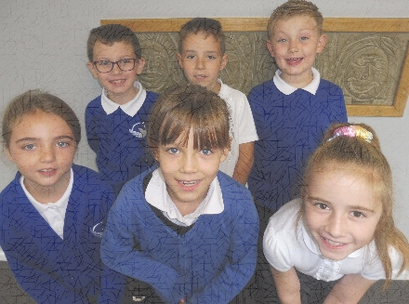
The results are in and have been verified!

We have two pupils from each class in each year group who have been voted in as pupil representatives. This is a great way to engage pupils as they will have a helping hand in making some important decisions such as the new lunch menus for the next term!

Our selected Year 3 members are very excited to be a part of the school council this year and we are looking forward to seeing what they do!
(Year 3 school Council)

Bikes on School Road

Please remember to supervise your child if they are riding their bike to school. We have had some concerns raised as children are riding their bikes along School Road during busy times and are potentially putting themselves and others in danger – both in the road and on the pavement. Please promote road safety with your child and remind them that it is necessary to wear a helmet when riding their bike.

Letters this week

Year 3 children will have received their letter regarding the use of SeeSaw today. Please ensure you complete and return it to the office as soon as possible as we would like to set this system up promptly.

Year 3 and Year 5 have been given details about our ‘Caveman Day’. We are very excited about the visit from Memma and her tribe and think it will be an excellent and engaging way for those children to learn about the stone age.

All children will have received their termly learning conference letter and a reply slip. Please hand these back to each of your children’s teachers and remember if you have more than one child here to complete a slip for each of them. This way we can try to ensure that the appointments you are given are close together.

Coats

I think we can all agree that there is a chill in the air at the moment! Please make sure that your child has a coat with them in school, as these will be necessary as break times get colder. We do get a lot of coats in lost property without labels, so please remember to add your child’s name!

Upcoming Dates:

Wednesday 23rd October – Parent Conferences - 3.30pm – 8pm.
Friday 25th October – Last day of this half term
Monday 28th October – Friday 1st November – Half Term Break
Monday 4th November – Return to School
Thursday 7th November – Year 3 Cavemen Experience
Friday 8th November – Year 5 Cavemen Experience
Friday 29th November – Non Pupil Day

