Year 3 Spring Term Homework – Linked to our Spring Curriculum
Create a plate  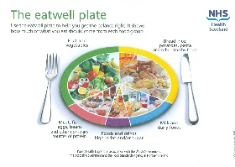  Can you draw a plate of dinner based on the NHS recommended balanced diet? Label the different foods you have included. | Let’s do a time walk  Create your own chronological timeline including the following periods of time: Celts, Romans, Stone Age, Saxons, Vikings, Normans, Tudors and Victorians. Include dates. | Shadows  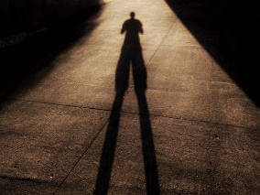  When the sun is out with the help from someone at home draw around the shadow they create. Take a photograph of the outline you have drawn. Compare the shadow to the person. What do you notice?
Pointillism  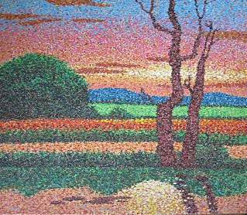  Create a picture of a something you can see outside using the pointillism technique. | Food, food, food  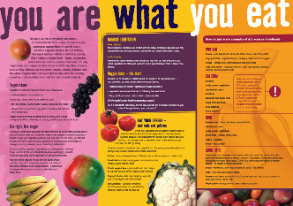  Create an information leaflet about how different foods are grown. | Understanding feelings  Draw one of the inside out characters. Around the outside write key words that are associated with this feeling e.g. Joy – happy, jumping, smiling etc
Create a ‘get active’ diary  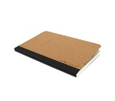  Record any exercise you have been a part of for a two-week period of time – this could be anything from walking, playing football or swimming. Record the day, time of day and how long you were active for in your diary. | George’s Marvellous Medicine  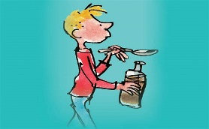  Create a poster – 5 top tips to staying healthy. Think about personal hygiene when creating your 5 top tips poster. | Get creative  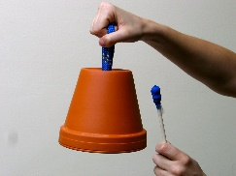  Create your own instrument using things you have at home.

