Our Curriculum Homework
A minimum of 5 pieces of homework must be completed from the grid. You can choose any 5 to complete, however one of them must be the central writing task.
Please hand all homework in to your class teacher by 16th December 2019.
Science  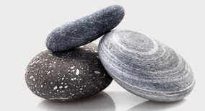  In Science we are learning about stones and rocks. Have a look around your house and garden. What kinds of rocks and stones can you find? Describe them. How are they different from each other? | Art  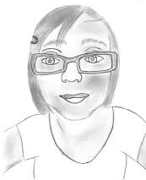  Use a mirror to sketch a self portrait using a range of tools. | Music  Practise singing the song ‘Sing’ by Gary Barlow. 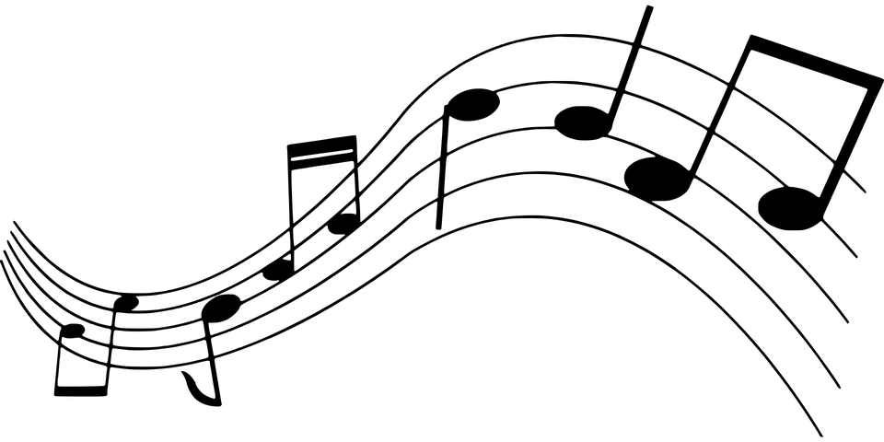
PSHE  Design a poster about being a good listener. Include pictures and sentences.  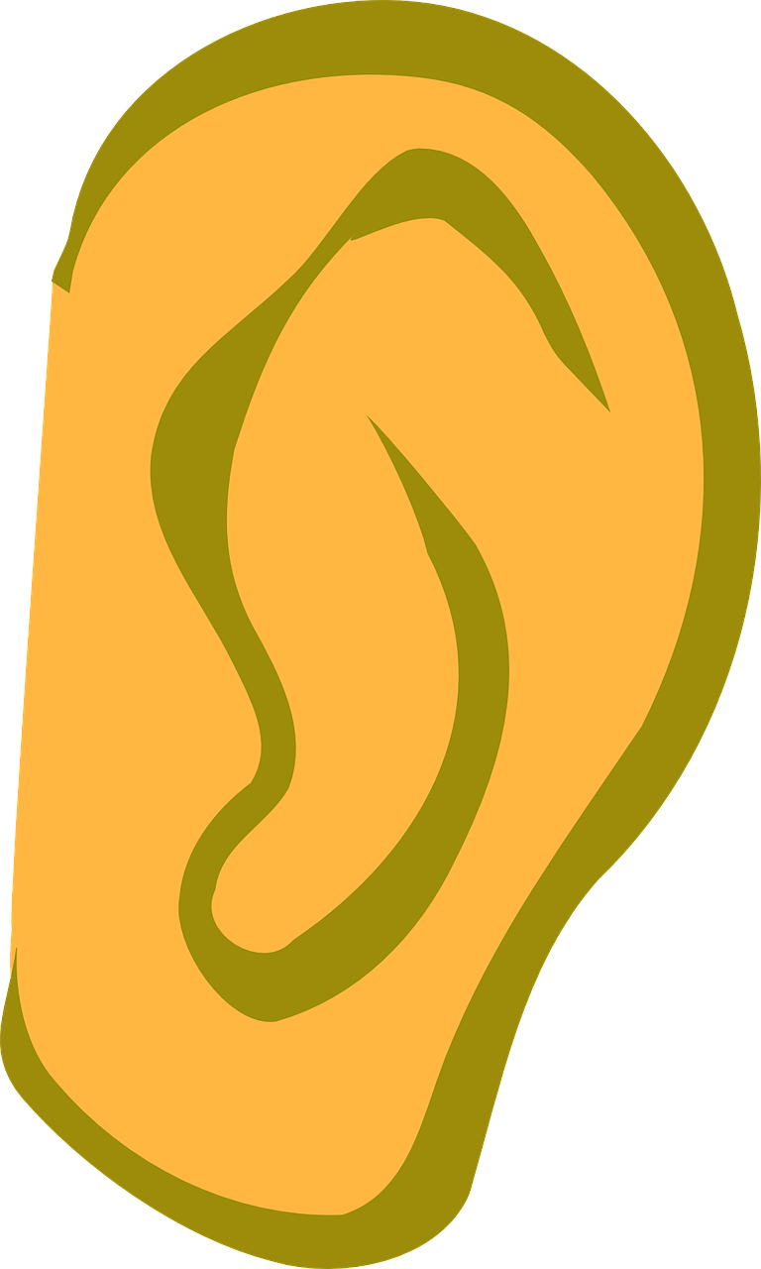 | Writing  You have gone through a tunnel and ended up somewhere completely different. Write a story about going through the tunnel and the magical place you ended up in.  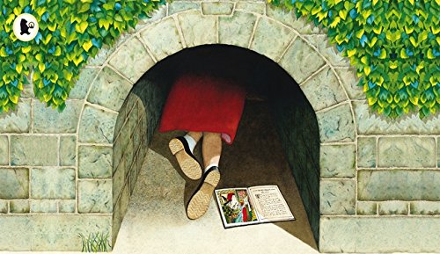 | History  Draw a Roman centurion (soldier) and label their armour.  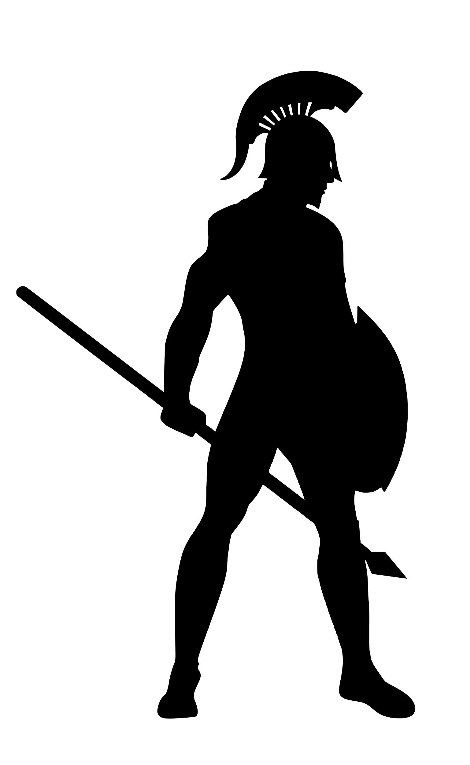
Reading  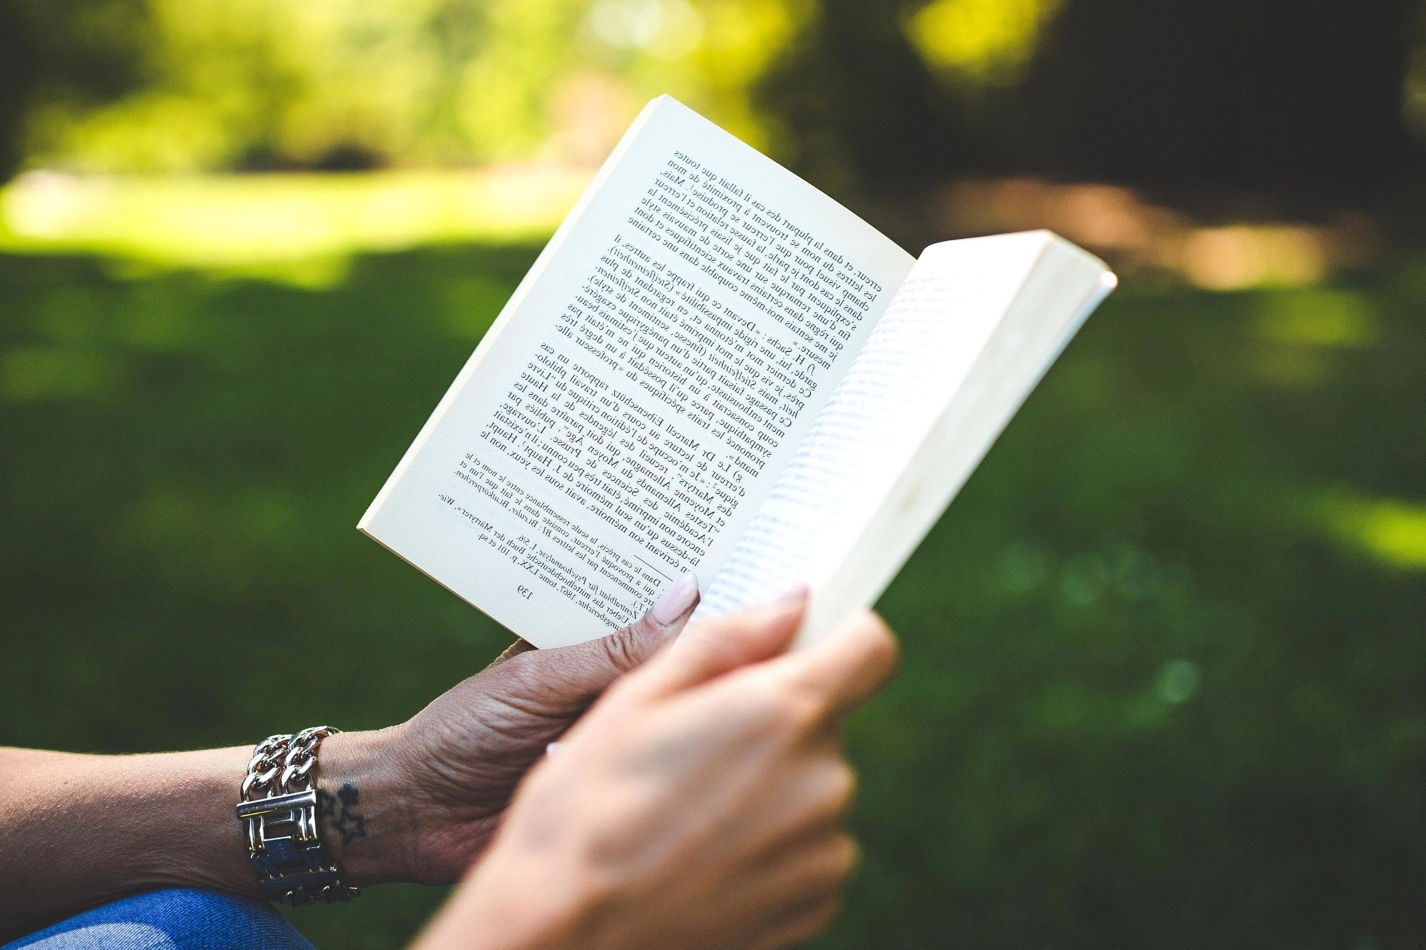  Write a review about a book you have at home. What did you like about the book? What didn’t you like? Why? | Maths  Once you have your TT Rockstars login, challenge one of your classmates to a battle.  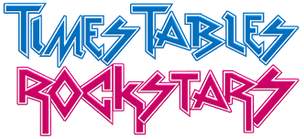 | Geography - Map work  Draw a map of your journey to and from school. Identify important landmarks.  