Homework: TRANSPORT (Year 4 - SPRING 2019)
Science – Explain how a lightbulb works | Maths: Design a playground. Ensure that you record the perimeter and area of it.  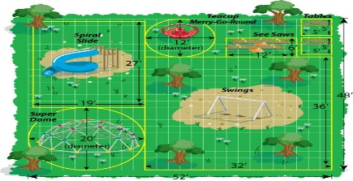 | Music: Can you find ten songs to do with transport or transportation? List the Artists and Song Title. The year recorded would also be good.  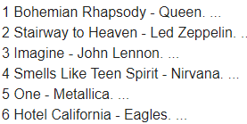
Science: Use recycled material to create your own musical instrument  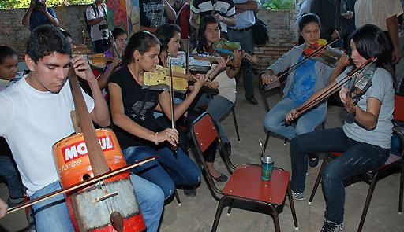 | Writing Activity (This activity must be completed):  Research the Titanic: Create an information sheet.  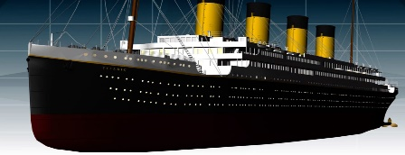 | History: Design a transport of the future. This could be an annotated drawing or a model.  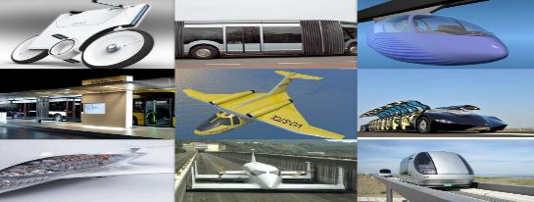
History: Plan a day out. Explain the routes you will need to take on the Underground.  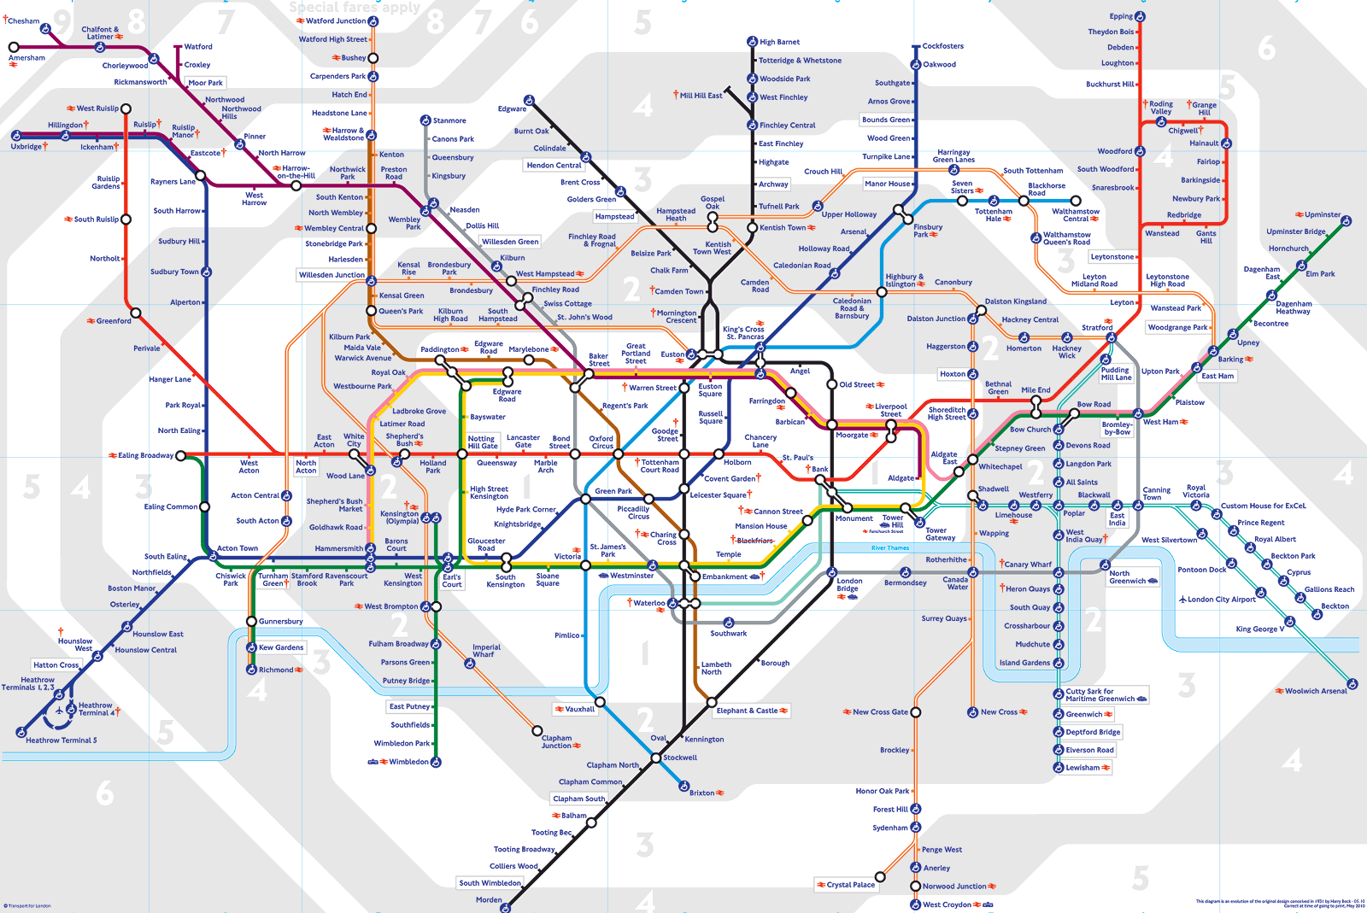 | Art: Sketch or paint a sunset using a range of colours  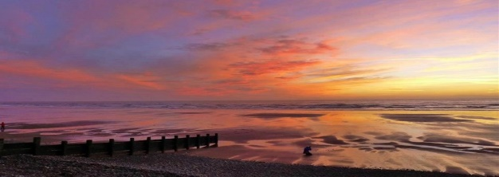 | History: The evolution of a bike - Create a fact file showing how the bike has changed over the years.  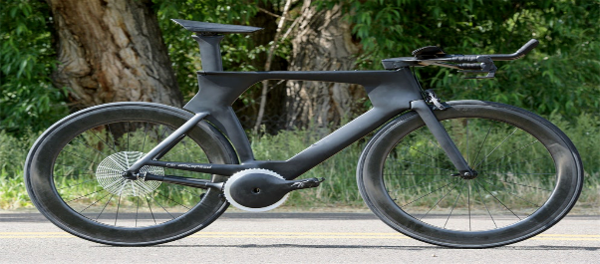
Remember that you need to read 3 times a week and practise your timetables. Please complete a minimum of 5 and hand in by 25/03/19. Thank you.

