Year 6 Spring Homework
You must complete at least 5 pieces by 5th April
Create a poster about BODMAS with examples of how to follow the order correctly.  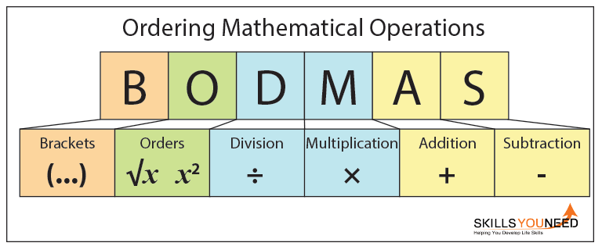 | Take an extract of a text (see example provided) and write 5 reading questions about it. Try to include a mix of retrieval and inference. | 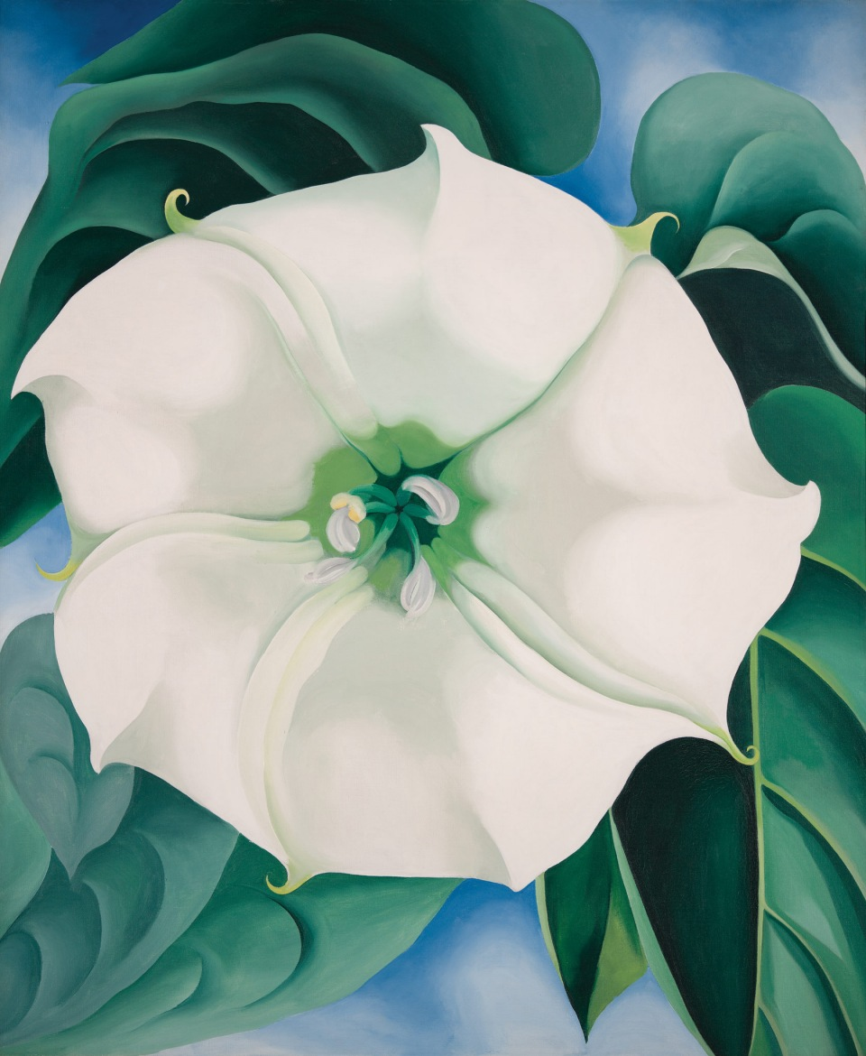  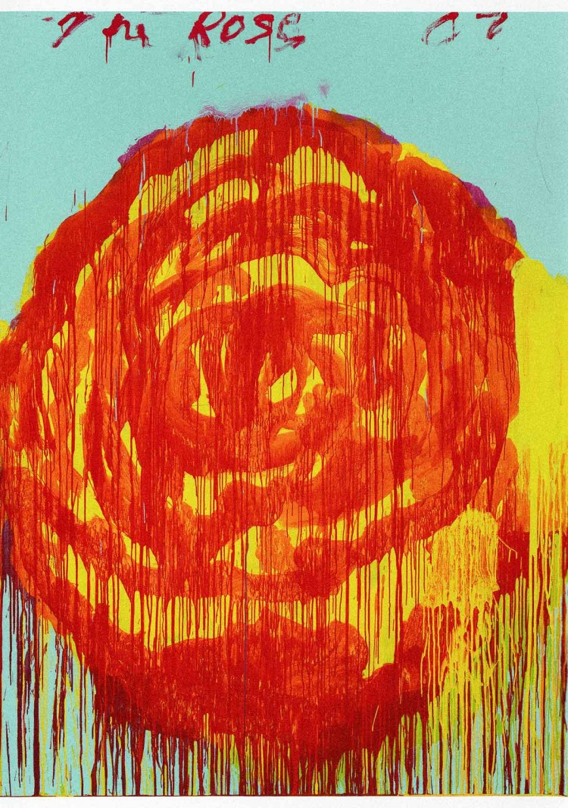  Find a flower to draw/paint in the style of Georgia O’Keeffe or Cy Twombly.
Find out what punishment at school was like during the Victorian era. | Write a diary entry of a character in a book that you are reading.  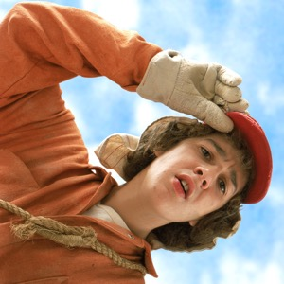 | Explain how to complete the four operations(+ - x ÷) with fractions to an adult or sibling. Write your notes in your book.
Create a 3D model of the heart or lungs.  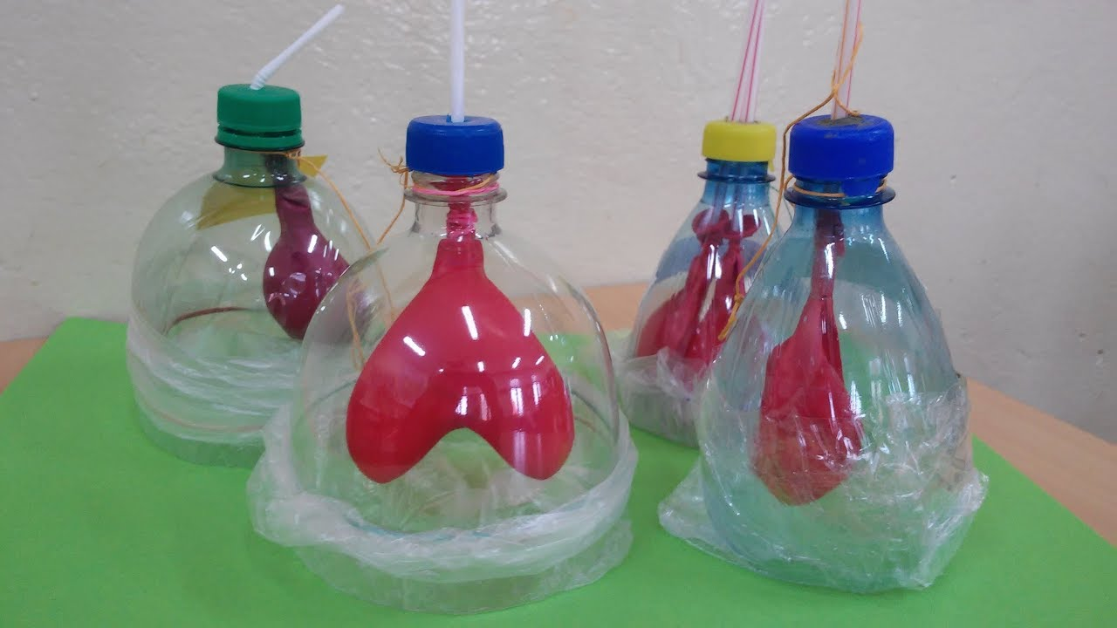 | Write a funny/amusing paragraph trying to use as many of the year5/6 spellings as possible. | Create your own set of maths loop card games to play in class (using year 6 maths).

