Year 5 Homework - SPRING 2019
Our Topics are: Medicine through History, Properties of Materials and Viking Adventures
Make a Viking Sword and Shield  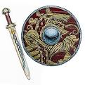 | Be the Teacher!  Write an explanation telling someone how to multiply 4 digits by 2 digits. Make sure you include all the steps and test it on a friendly adult!  If you want to, you can make a Powerpoint and teach the class.  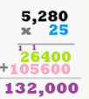 | Research what a Viking child did in a typical day.  Write a fact file to show your findings:  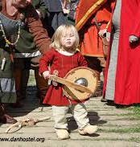  - Did Viking children go to school?  - What chores did Viking children have?  - What did Viking children eat?  - What else can you find out?
Describe the properties of the following metals and what they are used for:  - Copper  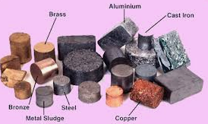  - Mercury  - Iron  - Calcium  - Lithium | Writing Activity (Compulsory)  Use your Year5 Skills  - Write a diary entry for a Viking child. Imagine you are a Viking child and describe your typical day.  - Write an account of a battle between Viking raiders and villagers. | Design a Poster  Your poster must explain what the 4 Humours are. Include symptoms that you might suffer from if one of your humours is imbalanced.  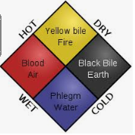  Make it colourful and striking.
Sound Insulation  You have experimented to find materials which conduct and insulate. Now conduct an experiment to see which materials insulate best against sound.  Wrap something which makes a noise (eg: phone) in various different materials. See which one makes the noise most quiet (1= quiet, 5=loud) and record your results in a table. | The Black Death  Imagine you live in Medieval Times and are suffering from the Plague. Describe your symptoms in a letter to your friend.  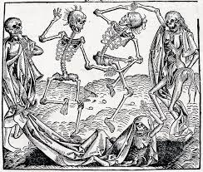 | What is the MMR vaccine?  Research the MMR and write fact file explaining what it does - make sure you describe fully the diseases it protects against.

