Year 5 Homework – Autumn 2019
Complete at least 5, including the centre, by 16th December.
Make a 3D Solar System  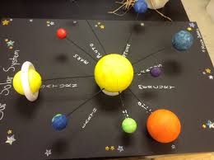 | Be the Teacher!  Write an explanation telling someone how to calculate the area and perimeter of 5 different objects e.g. table, note-book, DVD case etc.  Make sure you include all the steps and test it on a friendly adult!  If you want to, you can make a Powerpoint and teach the class. | Research your favourite famous leader from our history topic.  Write a fact file to show your findings:  - Who did they lead?  - What kind of leader were they?  - For what were they most famous?  - What else can you find out?  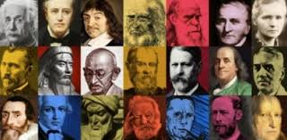
The eight compass points.  Create an eight point compass at home.  Remember to use the points name to label - not just the letter.  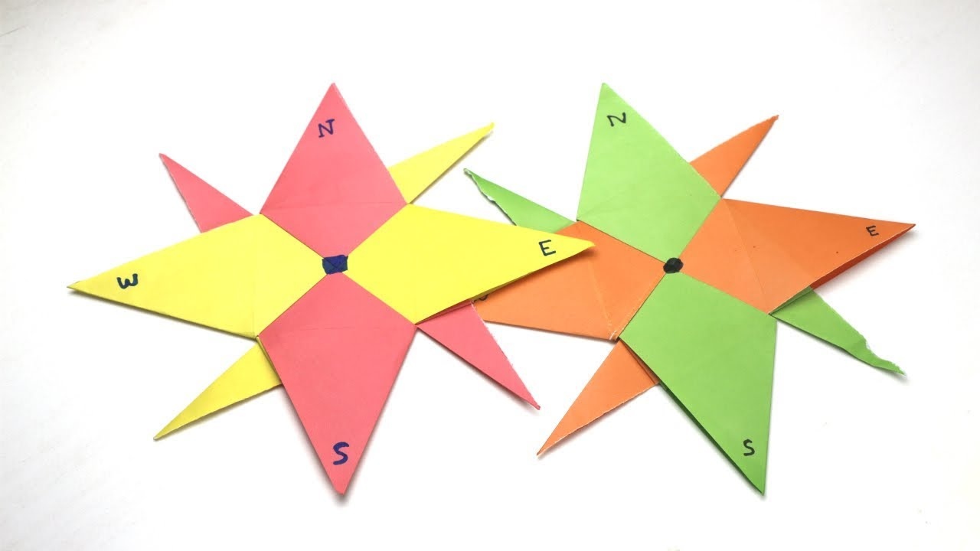 | Writing Activity (Compulsory)  Use your Year5 Skills  - Write a story where your character has had to work in a team to solve a problem..  - Write a diary entry of a famous world leader from one of the following choices:  Alexander the Great, Julius Cesar, Elizabeth I, Napoleon Bonaparte, George Washington, Winston Churchill and Martin Luther King. | Design a Poster  Create a poster celebrating what makes a great team.  Make it colourful and eye-catching..
Plan a holiday.  Create a holiday file  - What is the longitude and latitude of your chosen country?  - In what time-zone is it - how far ahead of the U.K is it?  - What direction would you need to travel to get there from home?  - Can you find some interesting facts about your country? | Forces- Water resistance  Can you make a boat that floats?  What shape do you need your boat to be?  Does the material from which your boat is made matter? | Draw a still life  Pose and draw your own pencil still life.  Remember to focus on light source and shading.  

