Homework: Natural Disasters, North America, Electricity (Year 4 - SUMMER 2019)
Geography – Fact sheet about Greenland (include a map)  Facts will include information about physical and human features.  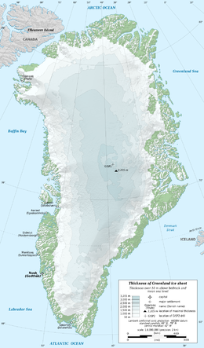 | Maths: Draw a bar chart of temperatures (maybe choose the highest of each season) of the different seasons experienced in Mexico and Canada. Are they the same?  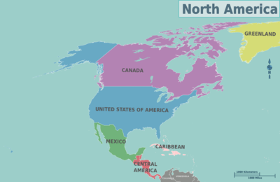 | Geography: Make a model of a volcano  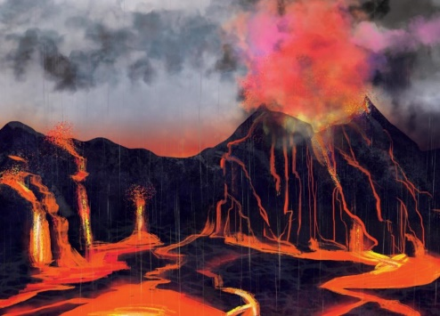
Science: Electricity – A diary of how many and how long electrical appliances are used in your home. | Writing Activity (This activity must be completed):  News report: Volcano almost destroys a town OR New island formed through vocano  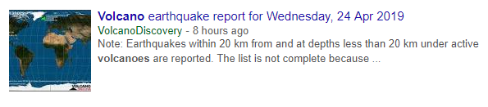 | Science: Food chains  Choose an animal. Research where your animal fits in the chain. Draw or make a food chain with that animal in it.  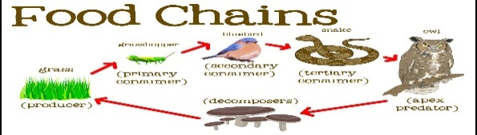
PE: Do any activity and measure your heart rate. Take a photo of yourself exercising and record your heart rate. Take more than one reading.  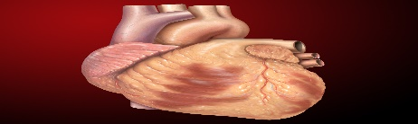 | Art: Collect things from your garden and create a collage of a scene after a storm  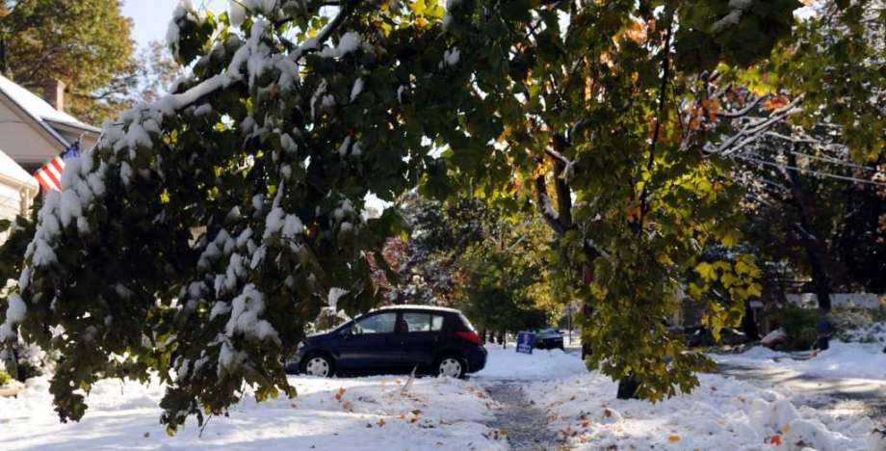 | French: Design a menu  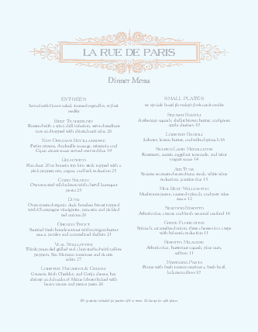
Remember that you need to read 3 times a week and practise your timetables. Please complete a minimum of 5 and hand in by 08/07/19. Thank you.

