Year 6 Summer Homework
You must complete at least 3 pieces by 15th July
Create an information poster about a city in Russia or China. | Why did the dodo become extinct?  Think about how it didn’t evolve to survive.  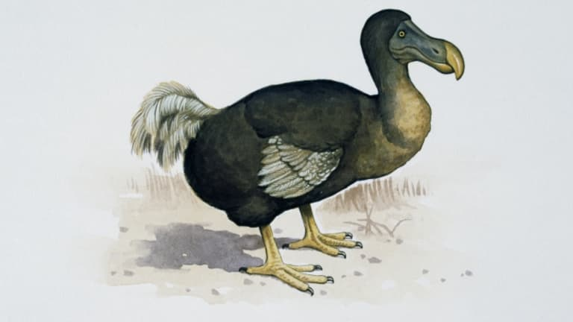 | Consider one family member (an adult) that you could invite to our afternoon tea.  Create a survey to find out their allergies/intolerances as well as food preferences.  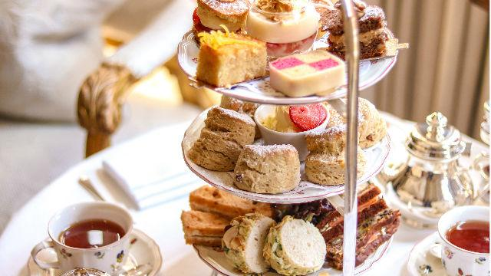
Draw and label a Lego creation that could use one of the Wedo features (motor, sensor, light or wheels)  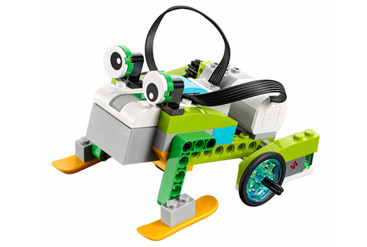 | What is the best book that you have read this year? Create a short book review to encourage others to read it too! | Create a comparison table for the U.K, Russia and China. You could include information such as lowest/highest temperatures, population etc.  