Year 5 Homework - Summer 2019
Our Topics are: Australia and India, Animals including humans and E-safety
Make a list of the online Apps and social networking sites you use and research the following:  How many users does the App/site have?  When was the App/site released/started?  What is the suggested minimum age to use the App/site?  Create a table to record your results. | Be a Statistician!  Interview your friends and family about their pets and record your findings in a two-way table.  Record the following things:  Type of Pet  Number of pets (by type)  Number of legs per pet  Total number of legs  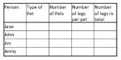 | Research the caste system in India  Find some information about what the caste system was and how it impacted life in India.  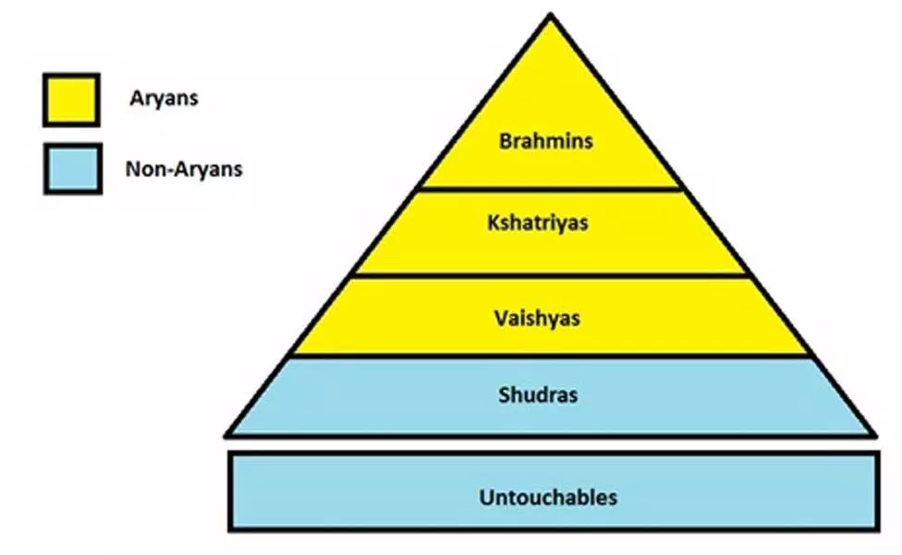
Investigate Sculpture  What is sculpture?  Can you find a picture of a sculpture you really like?  Who made it?  When did they make it?  How big is it?  What do you think of when you look at it?  How does it make you feel? | Writing Activity (Compulsory)  Use your Year 5 Skills  - Write a set of instructions for something about which you know well. Imaging that the reader knows nothing about it. Include illustrations to help the reader understand exactly what to do.  - Write your own fantasy story. Include details of characters and setting. Think about what life would be like without modern technology. | Design a Poster  Your poster must explain some of the cultural traditions across Australia and of India.  Make it colourful and striking. Think about food, music and language.
Stages of Foetal Development  Pick an animal of your choice and explain the stages of development from foetus to newborn. Can you find everyday objects which represent the changing size?  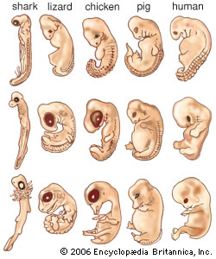 | The Australian Outback  Research a settlement located in the Australian outback and explain what life is like there. How have they adapted to the local environment? How is life different to life in Colchester?  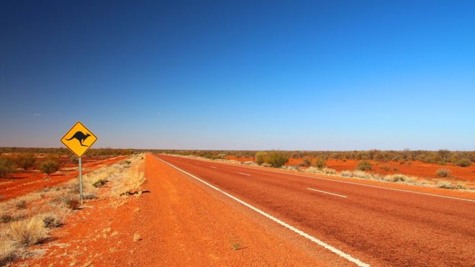 | Make a Timeline  Create an informative timeline explaining the life cycle of an average human being. Include pictures and important information.  