Our Homework: Summer Term

Science  Create a model of a flower including the roots, root hairs, stem, leaves and flower.  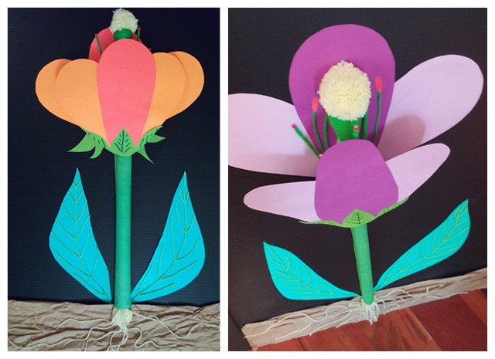 | Map work  Research the major rivers across the world. How many can you find? Record all the rivers by drawing them on to a map and labelling them.  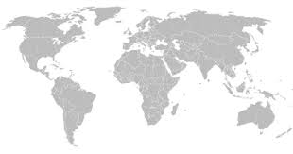 | Computing  Hide an object somewhere at home. Give someone directions to find the object e.g move 2 steps forward, turn right, turn left etc. Can they find where you have hidden the object?
PSHE  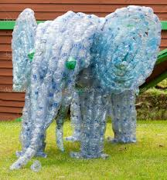  Use plastic waste from your house to make a sculpture of a figure. | English  All the teachers suddenly disappeared from Monkwick Junior School, the children were left to run the school for the day - what would happen? Write a story based on this scenario. | Modelling  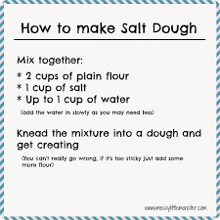  Using salt dough, create your own model of a country.
Maths  For one week, plot how many minutes a day you read on a line graph.  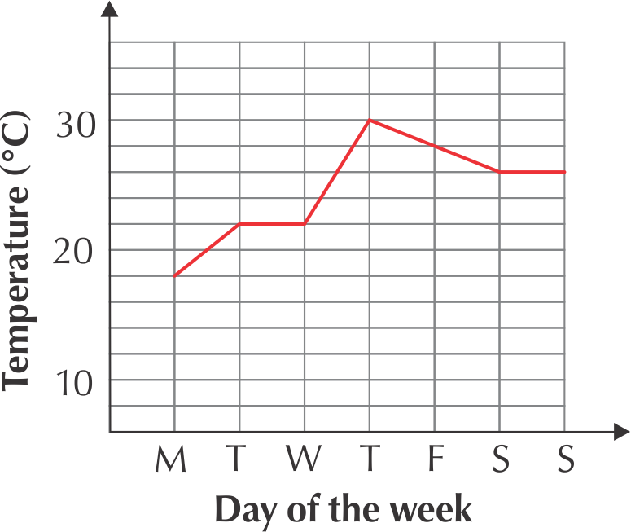 | French  Impress your friends and family with your French!  Introduce yourself to them, and teach them how to say hello and introduce themselves. | Geography  Competition! Find out as many facts about the animals living in the Amazon River as you can. Write your facts down, and see if you found the most!

