Monkwick Junior School – TEMPORARY Feedback and Marking Policy
September 2020

When we give feedback
-Feedback will be given verbally to pupils during the lesson.
-At the end of the lesson, the child will colour a spot or square red, yellow or green (see ‘Pupil marking and reflection’).
-Teachers will not mark any work or highlight the learning challenge after the lesson.

How we give feedback
-Adults will not provide any written comments or marks on work.
-Adults will not be able to circulate around the room to look at each child’s work.
-Children will not be able to hand in work to adults without a period of quarantine. This must be avoided but may be required for the marking of Big Maths work.
-Children can peer-mark some tasks, such as spelling tests, and give ticks in purple pen as well as verbal feedback to their partner.
- Teachers will give feedback by looking at the work of each child sitting in the front row. Each child will need to rotate their books so that this can be seen by the teacher at the front from the appropriate distance. All feedback will be verbal. Corrections and changes will be made by the child in purple pen.
- LSAs will give feedback by looking at the work of each child sitting in the back row. They will need to maintain the appropriate distance when reading this. All feedback will be verbal. Corrections and changes will be made by the child in purple pen.
- Books of children sitting in the middle row will not be able to be seen by an adult. Children sitting in the middle row will need to verbally share their responses in order to receive feedback from an adult. Corrections and changes will be made by the child in purple pen.
-Adults can ask pupils to show their method or write out a section of their work on their whiteboard in order to see if the child has made an error.

Additional support
-When a child is struggling during a lesson, teachers will need to ensure that the pupil receives additional support. This support will be provided by teachers on their own whiteboard by giving further models and examples. The appropriate distance must be maintained at all times.
-The child will complete their responses to this on their own whiteboard. Further verbal feedback will then be given by the teacher so that the child is able to continue independently.

Pupil marking and reflection
-At the end of the lesson, the child will colour a spot or square red, yellow or green.
-A visual success criteria will need to be shared at the end of each lesson by the teacher to help with completion.
-Coloured reflections and reasoning will be verbally shared with the teacher.
-Children can also write a written reflection at the end of their work to explain their choice of colour.
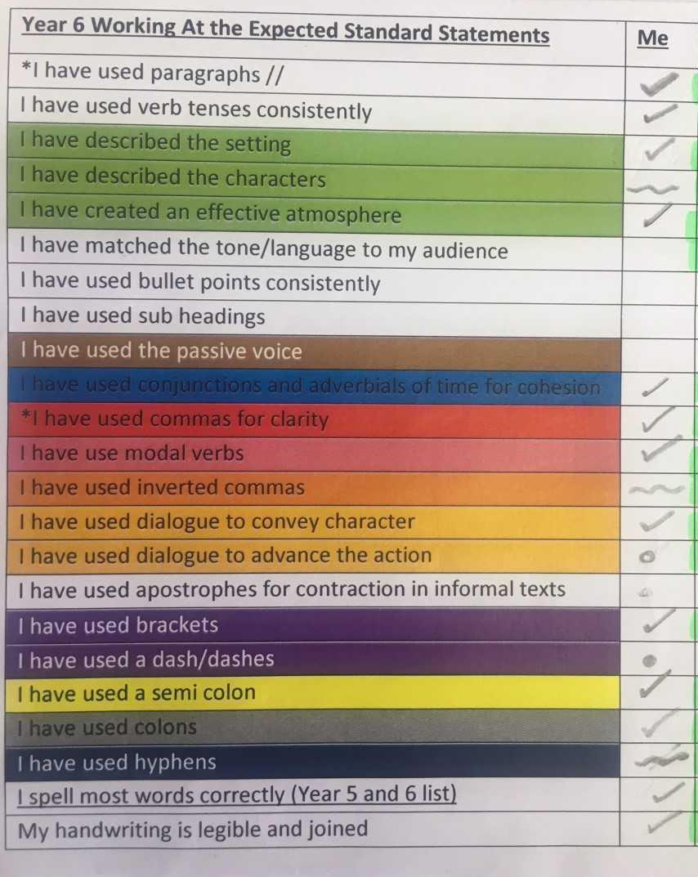
Pupil reflections will follow the ReflectEd colours:
All questions right first time/all success criteria completed - Green
Some questions correct/ all questions correct after more than one attempt/ some adult help needed to complete the task - Yellow
More questions incorrect than correct/extensive adult support needed - Red
Blue will not be used.
-Teachers will also provide specific paper copy success criteria lists for children to tick against as they complete extended writing. Teachers will not be able to highlight these but feedback can be given verbally to help with pupil completion. Children can also underline evidence of different criteria in the given colour.

